EVIDENCE REQUIREMENT

1. A COPY OF THE SQL CODE THAT COMPLETES EACH OF THE REQUESTED QUERIES
2. THE OUTPUT SHOWING THE RESULT FROM RUNNING THE QUERIES – USE SNIPPING TOOL TO SHOW THE OUTPUT

Q1. Check that each table will display the output presented in the individual tables

**view_users**

**view_orders**

**view_item**

Q2. Show the output from two of the adjacent tables in turn – that is orders and users; orders and item.

**view_users_orders**

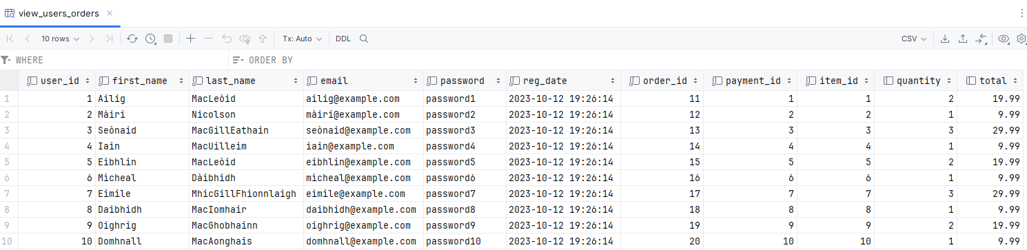

**view_orders_item**

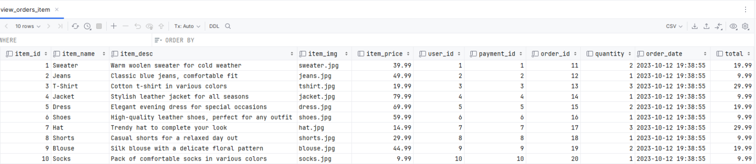

Q3. Connect all three tables and display the output that shows the output from these three tables – users, orders and item.

**view_users_orders_item**

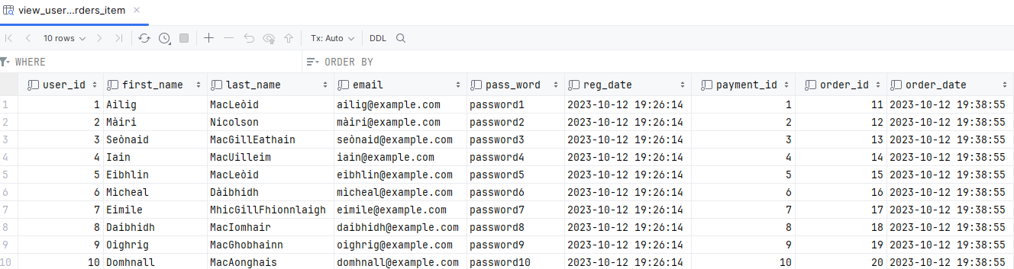

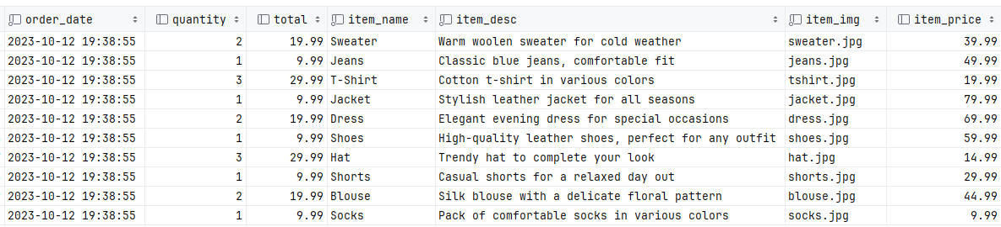

Q4. Create a query that will show the users and payment – so link these two tables and produce the output.

**view_users_payment**

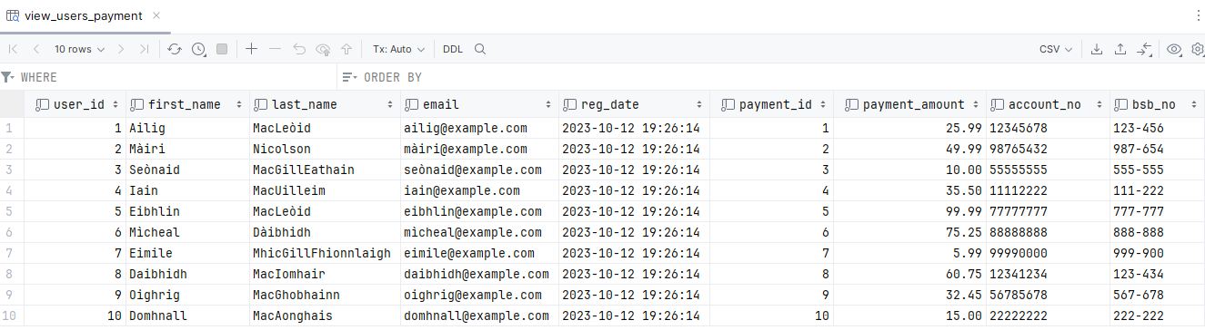

Q5. A manager wants to show a catalog of the items in the system and there quantities.

**view_item_cat**

